YEAR 3 HOME LEARNING
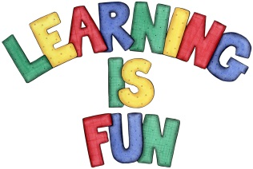
Date Set | 18/10/19
Date Due | 30/10/19
Mathletics | This week will be focussing our 2,3, 4 & 10 times table. We will also be measuring using a ruler, scales and grams and kilograms. And lastly, identifying patterns and sequencing to solve problems. All activities can be found on matheletics.com. Every child has their username and passwords in their reading records.
Spelling  Writing  Home Learning Project | This week children will be focusing on words with un- prefix.  unable unafraid unaided unaware unbeaten unblock uncertain unclean unclear  Writing Task  This week was inclusion week, we would like the children to research any black influencers from past or present. Then they should present their findings in any form they choose. For example, children can write a report, draw a portrait, make a poster, write a poem or a song.  Zakynthos Class Assembly is on the 1st November 2019.  Spetses Class Assembly is on the 8th November 2019.  Children are to create a book or a leaflet about living a healthy, active lifestyle. They can discuss things such as healthy eating, exercising and what our bodies need to stay healthy and strong. Due: November 1st 2019
Reading | Recommended daily reading time:  KS2 20 minutes.
Home Learning Project | Date Set:18.10.19 Date Due: 1.11.19
Greek | Please go to Greek Class Blog for Greek Home Learning  Greek Class - St Cyprian's Greek Orthodox Primary Academy

