YEAR 3 HOME LEARNING
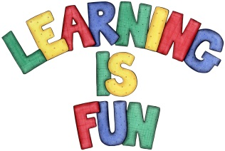
Date Set | 4.10.19
Date Due | 8.10.19
Maths | This week will be focussing our 2,3 & 4 times table. We will also be measuring using a ruler, scales and grams and kilograms. All activities can be found on matheletics.com. Every child has their username and passwords in their reading records.
Spelling  Writing | This week children will be focusing on words with mis- prefix.  - misheard  - misinform  - misinterpret  - misjudge  - mislay  - misread  - mislead  - mismanage  - misplace  - mispronounce  Writing Task  In class we have been learning how to find information from non-fiction sources. This week I would like you to write a report on your favourite animal. Try to include:  - Title  - Headings and subheadings.  - Statement sentences.  - Interesting information.  - Diagram  - Glossary
Reading | Recommended daily reading time:  KS2 40 minutes.
Greek | Please go to Greek Class Blog for Greek Home Learning  Greek Class - St Cyprian's Greek Orthodox Primary Academy

