YEAR 4 HOME LEARNING
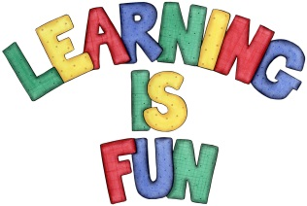
Date Set | 22/11/19
Date Due | 27/11/19
Mathletics | Next week in numeracy we will be learning about bar charts. Please check mathletics for extra home learning.
Spellodrome | This week’s spellings:  - supermarket  - superfood  - antiseptic  - antisocial  - interview  - happily  - information  - incorrect  - autobiography  - enthusiastically  Please check spellodrome for extra words.
Reading | Recommended daily reading time:  KS2 20 minutes.
Home Learning Project | This week for your home learning, I would like you to write a newspaper article about something that has happened in school this half term. It could also be about your trip to Hooke Court. Remember to include a scene setting opening, adverbials of time and place and FANBOYS.
Greek | Please go to Greek Class Blog for Greek Home Learning  Greek Class - St Cyprian's Greek Orthodox Primary Academy

