YEAR 2 HOME LEARNING
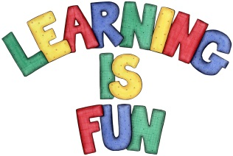
Date Set | 8.11.19
Date Due | 13.11.19
Mathletics | On Matheletics focus on subtraction and addition rules. All activities can be found on matheletics.com. Every child has their username and passwords in their reading records.
Spellodrome  Writing | Your Homework challenge this week is to write a recipe for your favourite food. You need to also include the following:  - What part of the world your cuisine is from and why is it your favourite dish?  - Photo or drawing of your favourite food  - Instructions on how to cook your favourite dish  - Ingredients list  - Imperative verbs (hold, rinse, wash, chop. cut, slice, stir etc.)  - Adverbs (slowly, carefully, quickly, etc.)  - Time Connectives (first, next, finally, after, before etc.)  Spellings to learn this week:  - table  - apple  - bottle  - little  - middle
Reading | Recommended daily reading time:  KS1 20 minutes.
Home Learning Project | Date Set: N/A Date Due:
Greek | Please go to Greek Class Blog for Greek Home Learning  Greek Class - St Cyprian's Greek Orthodox Primary Academy

