YEAR 2 HOME LEARNING
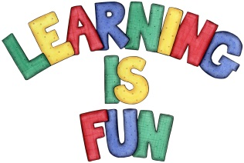
Date Set | 29.11.19
Date Due | 4.12.19
Mathletics | On Matheletics focus on fractions and finding ½, ¼ and ¾  of shapes and numbers. Additionally, focus on money and making different amounts using different coins as well as identifying and learning about the pound and pence sign. All activities can be found on matheletics.com. Every child has their username and passwords in their reading records.
Spellodrome  Writing | Your home learning challenge this week is to build upon your research skills and investigate any topic that you have an interest in and would like to explore. For example, you might want to use one of these ideas: Outer Space, kings and queens of the past, countries, volcanoes, endangered animals, rainforests, Tudors, Ancient Egyptians etc. and make an information poster about the topic.  You must include the following:  - Title  - Sub-headings  - Drawings with captions and labels  - Facts using bullet points to write short simple sentences  - Fun Facts  - Glossary  You must write at least a page  Spellings to learn this week  - pencil  - fossil  - nostril  - cry  - fly
Reading | Recommended daily reading time:  KS1 20 minutes.
Home Learning Project | Date Set: N/A Date Due:
Greek | Please go to Greek Class Blog for Greek Home Learning  Greek Class - St Cyprian's Greek Orthodox Primary Academy

