YEAR 3 HOME LEARNING
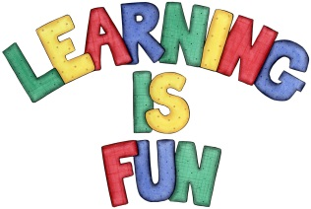
Date Set | 15/11/19
Date Due | 20/11/19
Mathletics | This week will be focusing our 2, 3, 4, 5, 8 and 10 times table as well as using the inverse to answer division questions. We will also be sorting, collecting and recording data using a Carroll Diagram and a Frequency Chart. All activities can be found on matheletics.com. Every child has their username and passwords in their reading records.
Spelling  Writing | This week children will be focusing on these words:  chorus scheme character Christmas school  stomach echo chemist monarch chaos  Writing Task  In class we have been learning about the features of instructions and how to write instructions. This week we would like you to write instructions for your favourite game. Include the following in your writing:  - Write in the present tense.  - Make a list of what you need.  - Include numbered steps.  - Use imperative verbs and adverbs in each step.  - Use time connectives and conjunctions.  - Use detailed descriptions.  Spellings to learn this week:  chorus scheme character Christmas school  stomach echo chemist monarch chaos
Reading | Recommended daily reading time:  KS2 20 minutes.
Home Learning Project
Greek | Please go to Greek Class Blog for Greek Home Learning  Greek Class - St Cyprian's Greek Orthodox Primary Academy

