YEAR 3 HOME LEARNING
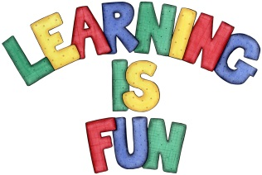
Date Set | 22/11/19
Date Due | 27/11/19
Mathletics | This week will be focusing our 3, 4 and 8-times table as well as using the inverse operation. We will also be learning how to add and subtract numbers up to and beyond 100 mentally. All activities can be found on matheletics.com. Every child has their username and passwords in their reading records.
Spelling  Writing | Spellings to learn this week:  Breath question century popular exercise  famous strange guard guide heart  Writing Task:  In class we have been learning about fantasy writing and its features. For your home learning this week you will be writing your own fantasy story. This story must be at least one page of writing.  It should include these features:  - Imaginary setting  - Good and bad characters  - Magic  - Conflict  - Talking animals  - A way into the fantasy world and a way out  - A problem and solution
Reading | Recommended daily reading time:  KS2 20 minutes.
Home Learning Project
Greek | Please go to Greek Class Blog for Greek Home Learning  Greek Class - St Cyprian's Greek Orthodox Primary Academy

