YEAR 3 HOME LEARNING
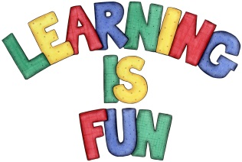
Date Set | 29/11/19
Date Due | 4/12/19
Mathletics | This week will be focusing on addition and subtraction of two and three digit numbers mentally. Practise your 2, 3, 4, 5, 8 and 10 times tables and counting in 1s, 2s, 3s, 5s and 10s using three digit numbers. All activities can be found on matheletics.com. Every child has their username and passwords in their reading records.
Spelling  Writing | This week children will be focusing on these words:  myth gym Egypt pyramid mystery dynasty symbol synagogue mysterious mystical  Writing Task  In class we have been learning how to use inverted commas for speech. This week we would like you to write a conversation between you and your friend. Include the following in your writing and write at least a page:  - Start speech with a capital letter  - Use a comma after said and before the inverted commas  - Use a full stop, question and exclamation mark before the closing inverted comma  - Use inverted comma over direct speech only, the first and last thing the character (you or your friend) says  - If a new character (you or your friend) speaks, it goes on the new line.  Spellings to learn this week:  myth gym Egypt pyramid mystery dynasty symbol  synagogue mysterious mystical
Reading | Recommended daily reading time:  KS2 20 minutes.
Home Learning Project
Greek | Please go to Greek Class Blog for Greek Home Learning  Greek Class - St Cyprian's Greek Orthodox Primary Academy

