YEAR 3 HOME LEARNING
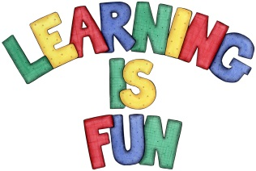
Date Set | 8/11/19
Date Due | 13/11/19
Mathletics | This week will be focusing our 2, 3, 4, 5, 8 and 10 times table as well as using the inverse to answer division questions. We will also be making and learning about reading and writing fractions. And lastly, collecting and recording data on a pictograph. All activities can be found on matheletics.com. Every child has their username and passwords in their reading records.
Spelling  Writing | This week children will be focusing on these words:  slippery winner pottery wrapped buzzing  planning shutting wedding forgotten forgetting  Writing Task  In class we have been learning about formal and informal letters. For your home learning this week choose one of the two forms and write a letter. It can be to anyone you like. This letter must be at least one page of writing.  It should include:  - Senders address  - Date  - Receivers address  - Greeting  - Main body  - Closing farewell  Spellings to learn this week:  slippery winner pottery wrapped buzzing  planning shutting wedding forgotten forgetting  Here’s a link for examples!  https://www.eslbuzz.com/how-to-write-a-letter-informal-and-formal-english/
Reading | Recommended daily reading time:  KS2 20 minutes.
Home Learning Project
Greek | Please go to Greek Class Blog for Greek Home Learning  Greek Class - St Cyprian's Greek Orthodox Primary Academy

