YEAR ___HOME LEARNING
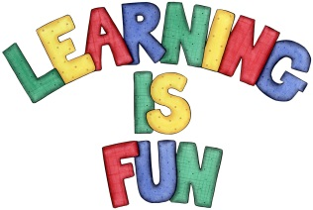
Date Set | 08/11/19
Date Due | 13/11/19
Mathletics | This week will be focussing on: interpreting data using tables. The children will need to log on to their Mathletics accounts that can be accessed form mathletics.com
Spellodrome | This week, children will be focusing on words with suffix –ent.  The children will only need to focus on the first 10 highlighted words for this week.  Spellings can also be found on spellodrome.com  - innocent  - confident  - decent  - disobedient  - independent  - intelligent  - consistent  - accident  - continent  - patient  - gradient  - convenient  - subsequent  - fluent  - memento  - apparent  - incident  - obedient  - insolent  - deterrent
Writing | Continuing on with the theme of non-fiction writing, children will be writing a biography on Isaac Newton. As we have focused on forces in Science, this is will be a relevant piece of writing, combining their knowledge of science and literacy.  Children must include:  - key facts about his life  - the biography should be written in the past tense  - chronological order  - should include time adverbials (e.g. whilst he was in studying in secondary school,...)
Reading | Recommended daily reading time:  KS2 40 minutes.
Home Learning Project | Date Set: N/A Date Due:
Greek | Please go to Greek Class Blog for Greek Home Learning  Greek Class - St Cyprian's Greek Orthodox Primary Academy

