YEAR 4 HOME LEARNING
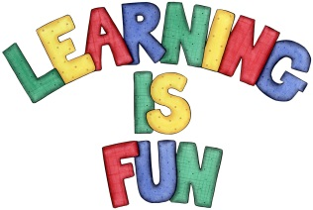
Date Set | 06/12/19
Date Due | 11/12/19
Mathletics | Next week in Maths we be learning about time and converting between 12 and 14 hour clocks. Mathletics has been set up with some revision of our work these last few weeks on decimals.
Spellodrome | 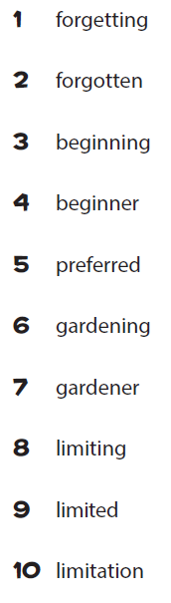  Please check spellodrome for extra words.
Reading | Recommended daily reading time:  KS2 20 minutes.
Home Learning Project | This week for your home learning, we would like you to write a Christmas story. It can either be one you have heard before, or you can make your own story up. The home learning is due in on Wednesday 11th December 2019.
Greek | Please go to Greek Class Blog for Greek Home Learning  Greek Class - St Cyprian's Greek Orthodox Primary Academy

