YEAR 4 HOME LEARNING
Date Set | 02/12/19
Date Due | 04/12/19
Mathletics | Next week in numeracy we will be learning about bar line graphs, Carrol Diagrams and we will be adding and subtracting numbers with decimals. Please check mathletics for extra home learning.
Spellodrome | 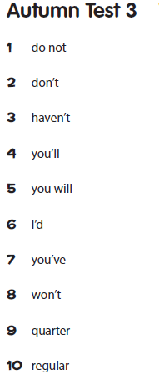  Please check spellodrome for extra words.
Reading | Recommended daily reading time:  KS2 20 minutes.
Home Learning Project | This week for your home learning, we would like you to create an autobiography. You should include all of the events in your life that are important to you. Your home learning is due Wednesday 4th December 2019.
Greek | Please go to Greek Class Blog for Greek Home Learning  Greek Class - St Cyprian's Greek Orthodox Primary Academy

