YEAR 2 HOME LEARNING
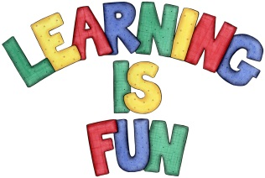
Date Set | 6.12.19
Date Due | 11.12.19
Mathletics | On Matheletics focus on fractions and finding ½, ¼ and ¾  of shapes. Additionally, focus on finding ½ and ¼ of numbers from the multiples of the 2 and 4 times tables. All activities can be found on matheletics.com. Every child has their username and passwords in their reading records.
Spellodrome  Writing | Your Homework challenge this week is to write a letter to Santa. You need to share with Santa all of your achievements this year and what you are proud of. You also need to include your New Year’s Resolutions and what you would like to achieve next year for 2020!!! You can even illustrate your letter. Remember to include:  - Your address on the top right of the letter (make this up and be as creative as you like)  - Santa’s address (make this up and be as creative as you like)  - Long date  - An opening explaining who you are and why you are writing to Santa  - You must include capital letters, full stops, conjunctions and ensure your sentences make sense  - Write in first person using (I)  - Adjectives to describe your feelings  You must write at least a page  Spellings to learn this week  - dry  - try  - reply  - July  - Flies
Reading | Recommended daily reading time:  KS1 20 minutes.
Home Learning Project | Date Set: N/A Date Due:
Greek | Please go to Greek Class Blog for Greek Home Learning  Greek Class - St Cyprian's Greek Orthodox Primary Academy

