YEAR 2 HOME LEARNING
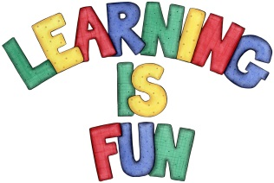
Date Set | 13.12.19
Date Due | 18.12.19
Mathletics | On Matheletics focus on addition and subtraction, multiples of 2, 5 and 10, fractions and finding ½, ¼ and ¾ of shapes. Additionally, focus on finding ½ and ¼ of numbers from the multiples of the 2 and 4 times tables and on money. All activities can be found on matheletics.com. Every child has their username and passwords in their reading records.
Spellodrome  Writing | Your Homework challenge this week is to research a world religion such as: Islam, Hinduism, Buddhism, Sikhism, Judaism (you can choose from the list or choose any other you would like to research. You must investigate and research facts about the religion. You might even decide to do Christianity and research about how Christmas is celebrated around the world. You must research:  - Who, how and where did the religion start  - Main beliefs  - Special places of worship or pilgrimage  - Special festivals, celebrations, customs and traditions  - Holy Books  - Symbols and meanings  - You must also include pictures, drawings, captions, labels, sub-headings, bullet points etc.  - Capital letters and full stops  You must write at least a page  Spellings to learn this week  - tries  - replies  - copies  - babies  - carries
Reading | Recommended daily reading time:  KS1 20 minutes.
Home Learning Project | Date Set: N/A Date Due:
Greek | Please go to Greek Class Blog for Greek Home Learning  Greek Class - St Cyprian's Greek Orthodox Primary Academy

