YEAR 2 HOME LEARNING
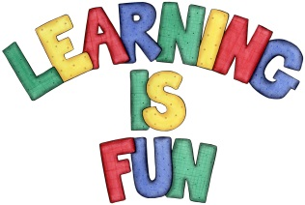
Date Set | 20.12.19
Date Due | 8.1.20
Mathletics | On Matheletics focus on addition and subtraction, multiples of 2, 5 and 10, fractions and finding ½, ¼ and ¾ of shapes. Additionally, focus on finding ½ and ¼ of numbers from the multiples of the 2 and 4 times tables and on money. If children are confident in the 2, 5 and 10 times tables please start learning the 3, 4 and 6 times tables. All activities can be found on matheletics.com. Every child has their username and passwords in their reading records.
Spellodrome  Writing | Your Homework challenge over the holidays is to research a famous sports person who is from the past or present. It could be a footballer, cricketer, athlete, swimmer, gymnast, dancer etc. (you can decide) and write a short biography about them. A biography is a non-fiction piece of writing which is real. It should describe aspects of a person’s life. You must include:  - Brief introduction on who you are writing about  - Information about their childhood  - Why they are famous  - Special achievements  - Why you chose to research them  - Capital letters and full stops, time connectives, conjunctions, and paragraphs  You must write at least a page  Spellings to learn this week  - copied  - copier  - happier  - happiest  - cried  - replied
Reading | Recommended daily reading time:  KS1 20 minutes.
Home Learning Project | Date Set: 20.12.19 Date Due: 8.1.20  Your home learning project for over the holidays is to create a booklet or a leaflet about what do humans need to stay healthy? In your writing must include:  - What is a healthy and balanced diet?  - What foods should we eat more of and less of-explaining why  - Research the food pyramid  - Why is exercise important for our bodies?  - What is personal hygiene and how do we keep our bodies healthy?  - Why do we need to look after our teeth and how do we do this?  - Headings and Subheadings  - Bullet points  - Photos or drawings with captions or labels
Greek | Please go to Greek Class Blog for Greek Home Learning  Greek Class - St Cyprian's Greek Orthodox Primary Academy

