YEAR 3 HOME LEARNING
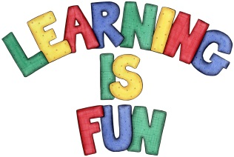
Date Set | 06/12/19
Date Due | 11/12/19
Mathletics | This week will be focusing our 3, 4 and 8-times table as well as using the inverse operation. We are also finding a unit fraction of a set of objects and lastly, identifying angles. All activities can be found on matheletics.com. Every child has their username and passwords in their reading records.
Spelling  Writing | Spellings to learn this week:  Young country cousin touch double  trouble couple courage flourish astronaut  Writing Task:  In class we have been learning about grammar, punctuations and report writing. For your home learning this week you will be writing your own report. This report must be at least one page.  It should include:  - introduction to topic  - reason to write about topic  - 2-4 subheadings and a paragraph for each  - apostrophes to show contraction and possession  - writing in past tense
Reading | Recommended daily reading time:  KS2 20 minutes.
Home Learning Project
Greek | Please go to Greek Class Blog for Greek Home Learning  Greek Class - St Cyprian's Greek Orthodox Primary Academy

