YEAR 3 HOME LEARNING
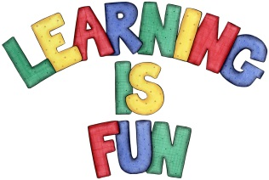
Date Set | 13/12/19
Date Due | 18/12/19
Mathletics | This week we will be focusing on counting from 0 in multiples of 2, 3, 4, 5, 8, 10, 50 and 100. Practise your 2, 3, 4, 5, 8 and 10 times tables and counting in 1s, 2s, 3s, 5s and 10s using three digit numbers. All activities can be found on matheletics.com. Every child has their username and passwords in their reading records.
Spelling  Writing | This week children will be revising the spellings covered in the Autumn term.  Writing Task  In class we have been learning how to use commas in a list. This week we would like you to write a letter to Father Christmas including a wish list as well as the following:  - Your address in the top right hand corner  - The date underneath the address  - An introductory paragraph to explain the purpose of the letter  - Include your wish list using commas  - A final paragraph to conclude the letter  - End with ‘Love from’.  Write at least a page.
Reading | Recommended daily reading time:  KS2 20 minutes.
Home Learning Project
Greek | Please go to Greek Class Blog for Greek Home Learning  Greek Class - St Cyprian's Greek Orthodox Primary Academy

