YEAR 3 HOME LEARNING
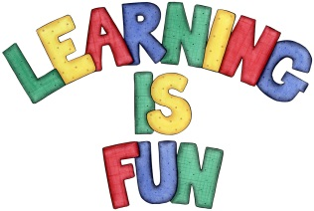
Date Set | 20/12/19
Date Due | 07/01/20
Mathletics | For the break please focus on the 2, 3, 4, 5 and 8-times table as well as using the inverse operation. Feel free to do times tables from 2-12. All activities can be found on matheletics.com. Every child has their username and passwords in their reading records.
Spelling  Writing | Spellings to learn for the Break:  young disapproved disqualified miscalculate mispronounce  cleverly parachute forgotten stomach question  Writing Task:  There will be no assigned writing task but, feel free to write about things you have done in the Christmas Break!
Reading | Recommended daily reading time:  KS2 20 minutes.
Home Learning Project | When you return from the break we will be learning about the Prehistoric Britain (Stone Age, Bronze Age and Iron Age). For your home learning project create a poster, leaflet or 3D Art teaching us about the lives of people back in those times.
Greek | Please go to Greek Class Blog for Greek Home Learning  Greek Class - St Cyprian's Greek Orthodox Primary Academy

