YEAR 2 HOME LEARNING
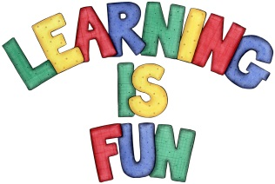
Date Set | 10.1.20
Date Due | 15.1.20
Mathletics | On Matheletics focus on writing simple fractions 1/2, 2/4, 1/4 and 3/4 and finding them in shapes. Focus on finding 1/2 and 1/4 of numbers. Also focus on reflective symmetry of shapes. If children are confident in the 2, 5 and 10 times tables please start learning the 3, 4 and 6 times tables. If children are secure in all of the above start learning the 7, 8 and 9 times tables. All activities can be found on matheletics.com. Every child has their username and passwords in their reading records.
Spellodrome  Writing | For your writing challenge you need to read one of your favourite fairy tales such as Cinderella, Little Red Riding Hood, Goldilocks and the Three Little Bears, Jack and the Bean stalk etc. and re-write the story in your own words. Focus on sequencing your story in the correct order and story language such as Once upon a time or in a faraway land etc.  You need to include in your writing:  - A beginning, middle and end to your story  - A description of the setting  - Introduction to characters  - Speech marks/inverted commas for talk  - Use of senses in your descriptions e.g. what you heard, smelt, saw, touch, tasted etc.  - Adjectives, time connectives, conjunctions  - Full stops and capital letters in the correct places.  - Paragraphs  You need to write at least a page for your story.  Spellings to learn this week  - hiking  - hiked  - hiker  - nicer  - nicest  - shiny
Reading | Recommended daily reading time:  KS1 20 minutes.
Home Learning Project | Date Set: Date Due:
Greek | Please go to Greek Class Blog for Greek Home Learning  Greek Class - St Cyprian's Greek Orthodox Primary Academy

