YEAR 2 HOME LEARNING
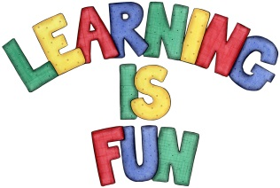
Date Set | 17.1.20
Date Due | 22.1.20
Mathletics | On Matheletics focus on position, direction and motion using straight lines, turns and co-ordinates. Also focus on measuring weight using grams and kilograms. If children are confident in the 2, 5 and 10 times tables please start learning the 3, 4 and 6 times tables. All activities can be found on matheletics.com. Every child has their username and passwords in their reading records.
Spellodrome  Writing | For your writing challenge this week you need to focus on writing a character profile for the Big Bad Wolf or the Big Bad Pig in the format of a wanted poster. In your character profile you need to focus on using adjectives, alliteration and writing longer sentences to describe the character. In your poster you must also include:  - A drawing of the Big Bad Wolf or the Big Bad Pig  - His crime explaining why he is wanted  - The reward for finding him  - Description of what he looks like  - What does he like to do and his hobbies?  - Where was he been seen last e.g. fleeing from the house made of bricks in a faraway forest.  - Who to contact if the Big Bad Wolf or the Big Bad Pig is seen or caught?  - Use of connectives to extend your sentences e.g. but, because, then, while, when etc.  - Full stops and capital letters in the correct places.  You need to write at least a page.  Spellings to learn this week  - patting  - patted  - humming  - hummed  - dropping  - dropped
Reading | Recommended daily reading time:  KS1 20 minutes.
Home Learning Project | Date Set: Date Due:
Greek | Please go to Greek Class Blog for Greek Home Learning  Greek Class - St Cyprian's Greek Orthodox Primary Academy

