YEAR 2 HOME LEARNING
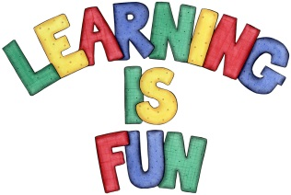
Date Set | 31.1.20
Date Due | 5.2.20
Mathletics | On Matheletics focus on finding the multiples of 5 and 10. Also focus on division and finding the inverse of operations. For example  15 ÷5 = 3 so 3x5=15. If children are confident in the 2, 5 and 10 times tables please start learning the 3, 4 and 6 times tables. If children are secure in all of the above start learning the 7, 8 and 9 times tables. All activities can be found on matheletics.com. Every child has their username and passwords in their reading records.
Spellodrome  Writing | We have read and explored the story of the Lonely Beast by Chris Judge. For your writing task this week you need to write at least 10 questions that you would want to ask the beast in an interview. You need to include in your writing:  - Who, why, what, when, where and how questions  - Have at least 3 two part questions. For example: What is your favourite food and why?  - End each question with a question mark  - Starting sentences with a capital letter  Golden Challenge: can you answer your questions as if you were the beast? (writing in first person) Remember to use full sentences and use I as you are the beast.  You need to write at least a page.  Spellings to learn this week  - all  - ball  - call  - walk  - talk  - always
Reading | Recommended daily reading time:  KS1 20 minutes.
Home Learning Project | Date Set: Date Due:
Greek | Please go to Greek Class Blog for Greek Home Learning  Greek Class - St Cyprian's Greek Orthodox Primary Academy

