YEAR 3 HOME LEARNING
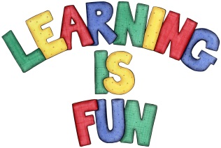
Date Set | 10/01/20
Date Due | 15/01/20
Mathletics | This week we will be focusing on rounding two and three-digit numbers to the nearest 10. We will also be estimating answers of addition and subtraction calculations. Please practice 2, 3, 4, 5, 8 and 10 times table as well as using the inverse to answer division questions. All activities can be found on matheletics.com. Every child has their username and passwords in their reading records.
Spelling  Writing | This week children will be focusing on these words:  donation adoration creation animation conversation  dictation decoration coronation duration information  Writing Task:  This half term we are learning about the Stone Age, Bronze Age and Iron Age. For your home learning this week, I would like you to research and write about Skara Brae. You might want to consider the following questions:  - What is Skara Brae?  - What are archaeologists and why are they important?  - What would life be like living in Skara Brae in the Stone Age?
Reading | Recommended daily reading time:  KS2 20 minutes.
Home Learning Project | We will be learning about the Prehistoric Britain (Stone Age, Bronze Age and Iron Age). For your home learning project create a poster, leaflet or 3D Art teaching us about the lives of people back in those times.  Date due: 17th January 2020.
Greek | Please go to Greek Class Blog for Greek Home Learning  Greek Class - St Cyprian's Greek Orthodox Primary Academy

