YEAR 3 HOME LEARNING
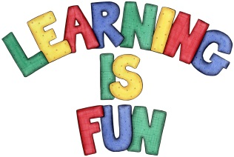
Date Set | 17/01/20
Date Due | 22/01/20
Mathletics | This week the children were finding adding and subtracting 3 digit numbers in column method challenging; especially when it comes to regrouping. Please practice this method at home! In addition, practice 2, 3, 4, 5, 8 and 10 times table as well as using the inverse to answer division questions. All activities can be found on matheletics.com. Every child has their username and passwords in their reading records.
Spelling  Writing | This week children will be focusing on these words:  sunburn footprint sunglasses familiar headache  factual diagonal skateboard earthquake shipwreck  Writing Task:  In class we have been reading and retelling a range of stories that are considered myths and legends. For your home learning you need to retell a legend that we have not done in class. Please put the story in your own words. It needs to be at least a page!  It should include:  - the date  - title  - summary  - apostrophes to show contraction and possession  - writing in past tense  - drawing.
Reading | Recommended daily reading time:  KS2 20 minutes.
Home Learning Project
Greek | Please go to Greek Class Blog for Greek Home Learning  Greek Class - St Cyprian's Greek Orthodox Primary Academy

