YEAR 3 HOME LEARNING
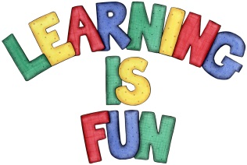
Date Set | 24/01/20
Date Due | 29/01/20
Mathletics | This week we will be focusing on addition and subtraction word problems including two and three-digit numbers. We will be solving addition and subtraction word problems using a column method. Please practice 2, 3, 4, 5, 8 and 10 times table as well as using the inverse to answer division questions. All activities can be found on matheletics.com. Every child has their username and passwords in their reading records.
Spelling  Writing | This week children will be focusing on these words:  dangerous poisonous cautious curious enormous  delicious courageous anxious devious envious  Writing Task:  Imagine you are a child in the Stone Age. Write a diary entry about your average day. What do you do in the day? What clothes do you wear? What do you eat? Where do you sleep?  Write at least a page.
Reading | Recommended daily reading time:  KS2 20 minutes.
Home Learning Project | We are learning about the Prehistoric Britain (Stone Age, Bronze Age and Iron Age). For your home learning project create a poster, leaflet or 3D Art teaching us about the lives of people back in those times.  Date due: 17th January 2020.
Greek | Please go to Greek Class Blog for Greek Home Learning  Greek Class - St Cyprian's Greek Orthodox Primary Academy

