YEAR 3 HOME LEARNING
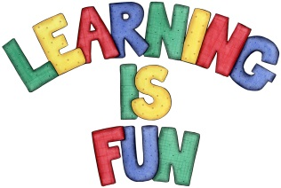
Date Set | 31/01/20
Date Due | 05/02/20
Mathletics | This week the children were finding telling time on an analogue clock challenging; especially when it came to distinguishing the different purposes of the long and short hand. Please practice this at home! In addition, practice 2, 3, 4, 5, 8 and 10 times table as well as regrouping column method. All activities can be found on matheletics.com. Every child has their username and passwords in their reading records.
Spelling  Writing | This week children will be focusing on these words:  bomb climb lamb tomb numb  doubt debt thumb limb subtle  Writing Task:  For your homework I would like you to research a Greek Myth. Write a summary about your chosen myth. I would like at least a page of writing.  It should include:  - the date  - title  - summary  - apostrophes to show contraction and possession  - writing in past
Reading | Recommended daily reading time:  KS2 20 minutes.
Home Learning Project
Greek | Please go to Greek Class Blog for Greek Home Learning  Greek Class - St Cyprian's Greek Orthodox Primary Academy

