YEAR 5 HOME LEARNING
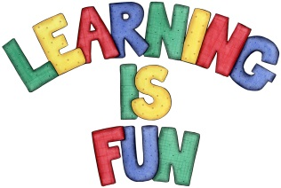
Date Set | 17/1/20
Date Due | 22/1/20
Mathletics | This week will be focussing on ordering fractions and decimals. The children will need to log on to their Mathletics accounts that can be accessed form mathletics.com
Spellodrome | This week, children will be focusing on the following words with the ible suffix.  Spellings can also be found on spellodrome.com  - deceive  - conceive  - receive  - perceive  - ceiling  - deceitful  - conceit  - receipt  - deceit  - conceited  - receiving  - conceivable  - received  - piece  - menace  - success  - fleecy  - exercise  - cinema  - century
Writing | This week children will be completing their 500-word narrative story for the BBC writing competition. Children must include clear sections to their story and include description and imagery (similes, metaphors, personification, show don’t tell).  Children should also use interesting sentence starters including fronted adverbials and include relative clauses.  Attached is a link to the BBC live lesson for children to go back and rewatch for guidance on how to plan their story.  https://www.bbc.co.uk/teach/live-lessons
ER | Recommended daily reading time:  KS2 40 minutes.
Home Learning Project | Date Set: N/A Date Due:
Greek | Please go to Greek Class Blog for Greek Home Learning  Greek Class - St Cyprian's Greek Orthodox Primary Academy

