YEAR 4 HOME LEARNING
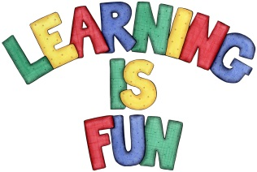
Date Set | 17/01/20
Date Due | 22/01/20
Mathletics | Please check Mathletics for extra home learning.
Spellodrome | - submarine  - submerge  - submission  - subcontract  - subtitle  - subsequent  - substandard  - subordinate  - subterranean  - subcommittee  Please check spellodrome for extra words.
Reading | Recommended daily reading time:  KS2 20 minutes.
Home Learning Project | This term our science challenge question is, ‘What happens to the food we eat?’. For your home learning I would like you to create a piece of learning to answer this question. It could be a poster, a fact file, a piece of writing, a leaflet etc. This home learning is due Wednesday 22th January 2020.
Greek | Please go to Greek Class Blog for Greek Home Learning  Greek Class - St Cyprian's Greek Orthodox Primary Academy

