YEAR 2 HOME LEARNING
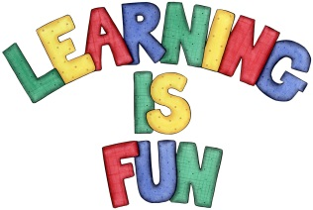
Date Set | 7.2.20
Date Due | 12.2.20
Mathletics | On Matheletics focus on solving multiplication statements and word problems. Also focus on reading temperature on a thermometer scale. If children are confident in the 2, 5 and 10 times tables please start learning the 3, 4 and 6 times tables. If children are secure in all of the above start learning the 7, 8 and 9 times tables. All activities can be found on matheletics.com. Every child has their username and passwords in their reading records.
Spellodrome  Writing | We have been continuing to read and explore the story of the Lonely Beast by Chris Judge.  For your writing task this week you need to write your own ending for the story and predict what you think will happen next and how the problem will be resolved. You need to include in your writing:  - An explanation of what is going to happen next; now that the lonely beast has spoken to the media.  - A clear ending where the problem is resolved well.  - A description of the beast’s feelings throughout the story using adjectives  - Include speech between two characters including speech marks and exclamation marks to increase tension and suspense!  - Capital letters, full stops and paragraphs  - Include conjunctions, time connectives, adverbs, verbs and imperative verbs.  You need to write at least a page.  Spellings to learn this week  - other  - mother  - brother  - nothing  - Monday
Reading | Recommended daily reading time:  KS1 20 minutes.
Home Learning Project | Date Set: Date Due:
Greek | Please go to Greek Class Blog for Greek Home Learning  Greek Class - St Cyprian's Greek Orthodox Primary Academy

