YEAR 2 HOME LEARNING
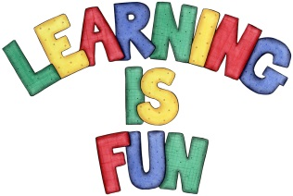
Date Set | 14.2.20
Date Due | 26.2.20
Mathletics | On Matheletics focus on finding the multiples of 5 and 10. Also focus on division and finding the inverse of operations and word problems. For example 15 ÷5 = 3 so 3x5=15. If children are confident in the 2, 5 and 10 times tables please start learning the 3, 4 and 6 times tables. If children are secure in all of the above start learning the 7, 8 and 9 times tables. All activities can be found on matheletics.com. Every child has their username and passwords in their reading records.
Spellodrome  Writing | Your Homework challenge over the holidays is to pretend that you are at a luxurious holiday resort surrounded by a beautiful seaside. You need to either write a letter or design and write a postcard to your friend. In your letter or postcard, you must include:  - What have you been doing on your holiday?  - What you have done so far and what you are going to do e.g. take a boat trip, swim with dolphins, go on rides?  - What has been your favourite part of your holiday?  - What are the features of the seaside resort and attractions?  - What can you do at the seaside?  You need to write at least a page.  Spellings to learn this week  - key  - donkey  - monkey  - chimney  valley
Reading | Recommended daily reading time:  KS1 20 minutes.
Home Learning Project | Date Set: 14.2.20 Date Due: 26.2.20  You can choose which one of the two home learning projects you can complete. You can either:  - Design your very own seaside resort out of recyclable materials. Think about what you would like at the seaside and some of the features that seaside resorts have.  or  - Create and make your own musical instrument made from recyclable materials.
Greek | Please go to Greek Class Blog for Greek Home Learning  Greek Class - St Cyprian's Greek Orthodox Primary Academy

