YEAR 1 HOME LEARNING
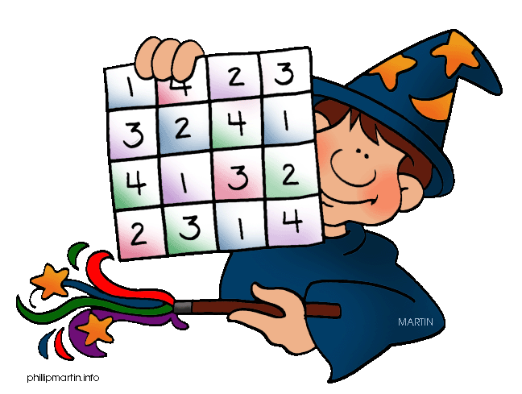
Date Set | 07.02.20
Date Due | 12.02.20
Purple Mash | Addition  Logins in Pink books (Skiathos)/ in reading records (Cyprus).
Writing | Online literacy- Purplemash  This week we would like the children to complete the activity ‘Growing Plant’ - Can you describe what happens as a plant grows?  Additional activities; phonics, create a story. To be completed by Wednesday 12th February.
Reading/  Phonics | Recommended daily reading time:  KS1 15-20 minutes  Revise set 2 and 3 sounds
Home Learning Project | Date Set: 17.01.20 Date Due: 24.02.20  Year 1 Home Learning  Our topic this half term is ‘What birds and plants would little Red Riding Hood see in our park?’  Your challenge is to create a poster or leaflet about the birds and plants Little Red Riding Hood would see around our parks. We look forward to seeing your projects!  If you need any help please see Mrs Richards or Miss Moloney.
Greek | Please go to Greek Class Blog for Greek Home Learning  Greek Class - St Cyprian's Greek Orthodox Primary Academy

