YEAR 3 HOME LEARNING
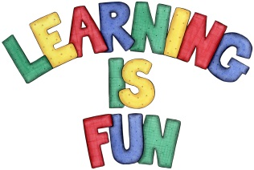
Date Set | 14/02/20
Date Due | 26/02/20
Mathletics | This week please continue practice telling time on an analogue clock with your children. In addition, practice 2, 3, 4, 5, 8 and 10 times table as well as Multiplying 2-digit numbers by 1-digit numbers. All activities can be found on matheletics.com. Every child has their username and passwords in their reading records.
Spelling  Writing | This week children will be focusing on these words:  science scene crescent fascinating ascent scissors scented scientist descend score  For your homework I would like you to write a book review on any book you have read over the break. I would like at least a page of writing.  It should include:  - the book title  - the author  - was the book fiction or non-fiction  - What was the book about?  - Who would you recommend the book to? Why?  - Book illustration (drawing)  - What ages and interest is this book suitable for? Why?  - What would you rate this book? Lowest 1 2 3 4 5 Highest
Reading | Recommended daily reading time:  KS2 20 minutes.
Home Learning Project | Research about magnets and create a poster showing what you have learnt.  Due: Wednesday March 4th 2020
Greek | Please go to Greek Class Blog for Greek Home Learning  Greek Class - St Cyprian's Greek Orthodox Primary Academy

