YEAR 3 HOME LEARNING
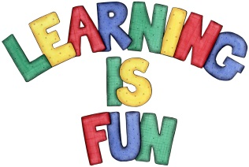
Date Set | 7/02/20
Date Due | 12/02/20
Mathletics | This week we will be focusing on identifying horizontal, vertical, diagonal, perpendicular and parallel lines. We will also be learning to use a written method to multiply two-digit numbers by one-digit numbers. Please practice 2, 3, 4, 5, 8 and 10 times table as well as using the inverse to answer division questions. All activities can be found on matheletics.com. Every child has their username and passwords in their reading records.
Spelling  Writing | This week children will be focusing on these words:  antique boutique mosque opaque cheque  plaque technique  unique critique grotesque  Writing Task:  The home learning challenge for this week is to create a character profile for one of your favourite myths. You need to include in your writing:  - A description of what they look like, their appearance  - A description of what they enjoy doing, their powers etc.  - A description of their personality (what type of person are they?)  - Sentences that make sense  - Punctuation in the correct places e.g. full stops and capital letters.  Write at least a page.
Reading | Recommended daily reading time:  KS2 20 minutes.
Home Learning Project | We are learning about the Prehistoric Britain (Stone Age, Bronze Age and Iron Age). For your home learning project create a poster, leaflet or 3D Art teaching us about the lives of people back in those times.  Date due: 17th January 2020.
Greek | Please go to Greek Class Blog for Greek Home Learning  Greek Class - St Cyprian's Greek Orthodox Primary Academy

