YEAR 4 HOME LEARNING
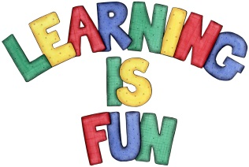
Date Set | 24/02/20
Date Due | 04/02/20
Mathletics | Please check Mathletics for extra home learning. Please ensure you are completing this at home. It consolidates the children’s learning that they have been doing in school.
Spellodrome | - brochure  - machine  - chef  - chalet  - chandelier  - crochet  - parachute  - moustache  - champagne  - ricochet  Please check spellodrome for extra words.
Reading | Recommended daily reading time:  KS2 20 minutes.
Greek | Please go to Greek Class Blog for Greek Home Learning  Greek Class - St Cyprian's Greek Orthodox Primary Academy

