02/02/15
LO: To measure volumes of liquid
For each item, estimate the volume of liquid that it can hold and then use the measuring jug to measure the actual amount it can hold.

Item | Estimate | Actual Volume
Small bottle |  | 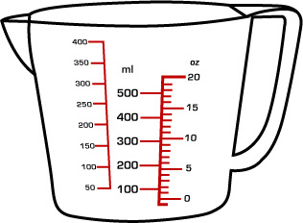
Large glass
Egg cup
Tupperware container
Coffee mug
Watering can

Which object has the largest volume? _____________________

Which object has the smallest volume? ____________________

Which was your closest estimate? ______________________

What was the total volume of the coffee mug and the egg cup added together? _______________

How much bigger was the large glass than the small bottle?
__________________________________

