YEAR 2 HOME LEARNING
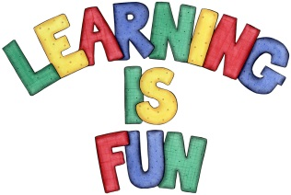
Date Set | 6.3.20
Date Due | 11.3.20
Mathletics | On Matheletics focus on finding Greater than and Less Than and Rounding numbers to the nearest 10. Also focus on the properties of 2D and 3D shapes. If children are confident in the 2, 5 and 10 times tables please start learning the 3, 4 and 6 times tables. All activities can be found on matheletics.com. Every child has their username and passwords in their reading records.
Spellodrome  Writing | In literacy this week we have been writing our own ‘Explanation Texts’ on the life cycle of a butterfly. We have learnt that Explanation Texts explain to us how a process works. For your writing challenge this week we would like you to create an Explanation Text on the life cycle of a frog. You need to include in your writing:  - Pictures/diagrams of each step of the cycle  - Ordered paragraphs/sections  - Joining words (because, this means, so etc)  - Comparative words (brighter, smaller, stronger etc)  - Technical vocabulary (tadpole, spawn etc)  - Full stops and capital letters in the correct places.  Present your learning in a creative way and write at least a page for your explanation text.  Spellings to learn this week:  - word  - work  - worm  - world  - worth
Reading | Recommended daily reading time:  KS1 20 minutes.
Home Learning Project | Date Set: Date Due:
Greek | Please go to Greek Class Blog for Greek Home Learning  Greek Class - St Cyprian's Greek Orthodox Primary Academy

