YEAR 2 HOME LEARNING
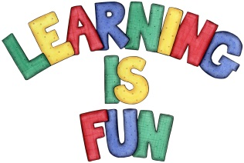
Date Set | 13.3.20
Date Due | 18.3.20
Mathletics | On Matheletics focus on estimating numbers and calculations as well as finding the inverse (opposite) of number calculations to check that answers are correct. If children are confident in the 2, 5 and 10 times tables please start learning the 3, 4 and 6 times tables. All activities can be found on matheletics.com. Every child has their username and passwords in their reading records.
Spellodrome  Writing | This week in literacy we have read and explored the story of the Brave Beast by Chris Judge.  For your writing challenge you need to write a character profile for one of the beasts living in a different country. You need to include in your writing:  - A description of what they look like  - A description of what they enjoy doing  - A description of their personality (what type of person are they?)  - Sentences that make sense.  - Punctuation in the correct places e.g. full stops and capital letters.  Write at least a page for your character profile.  Spellings to learn this week:  - war  - warm  - towards  - television  - treasure  - usual
Reading | Recommended daily reading time:  KS1 20 minutes.
Home Learning Project | Date Set: Date Due:
Greek | Please go to Greek Class Blog for Greek Home Learning  Greek Class - St Cyprian's Greek Orthodox Primary Academy

