YEAR 2 HOME LEARNING
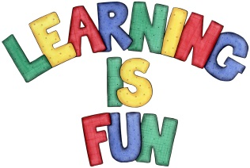
Date Set | 20.3.20
Date Due | 25.3.20
Mathletics | On Matheletics focus on writing the more than and less than symbols when ordering and comparing numbers and focus on the properties of 2D and 3D shapes. If children are confident in the 2, 5 and 10 times tables please start learning the 3, 4 and 6 times tables. All activities can be found on matheletics.com. Every child has their username and passwords in their reading records.
Spellodrome  Writing | This week in literacy we have been continuing to read and explore the story of the Brave Beast by Chris Judge. For your writing challenge you need to write your own adventure story including an opening, a logical sequence of events and an ending. Please also include interesting characters and a dialogue to show how characters think and feel; joining words to link events and interesting verbs, adjectives and adverbs.  You need to include in your writing:  - A clear opening introducing your characters and setting  - A logical sequence of events  - A clear ending where the problem is resolved  - A description of the characters  - Punctuation (capital letters, full stops, exclamation marks and question marks)  - Openers to start your paragraphs/ sentences (suddenly, at last, meanwhile, after etc.)  - Conjunctions to join your sentences  - Using direct speech between two characters including speech marks  Write at least a page for your adventure story.  Spellings to learn this week:  - enjoyment  - sadness  - careful  - playful  - hopeless  - plainness  - badly
Reading | Recommended daily reading time:  KS1 20 minutes.
Home Learning Project | Date Set: Date Due:
Greek | Please go to Greek Class Blog for Greek Home Learning  Greek Class - St Cyprian's Greek Orthodox Primary Academy

