

**Plants Need...**

Use the words below to finish the sentences.

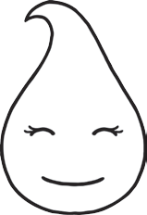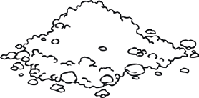

**light**

**water**

**air**

**soil**

Many plants need from the sun.

Many plants need or they will dry out.

Many plants need to grow their roots in.

They get the nutrients they need from the soil.

Plants need , and

which they use to make food.

Plants need these four things:

**visit twinkl.com.au**

**Plants Need…**

**My Pictures of What Plants Need**

1. w

2. a

3. s

4. l





Plants Need... **Answers**

Use the words below to finish the sentences.

**light**

**water**

**air**

**soil**

Many plants need **light** from the sun.

Many plants need **water** or they will dry out.

Many plants need **soil** to grow their roots in.

They get the nutrients they need from the soil.

Plants need **light**, **water** and **soil** which they use to make food.

Plants need these four things:

**visit twinkl.com.au**

**Plants Need…**

**My Pictures of What Plants Need**

**1. water**

**2. air**

**3. soil**

**4. light**