YEAR 3 HOME LEARNING
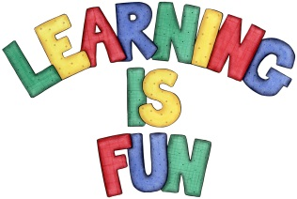
Date Set | 06/03/20
Date Due | 11/03/20
Mathletics | This week please practice adding and subtracting money with your children. In addition, practice dividing 2-digit numbers by 1-digit numbers, using the short division method. All activities can be found on matheletics.com. Every child has their username and passwords in their reading records.
Spelling  Writing | This week children will be focusing on these words:  supermarket subject subheading interchange superior  superstar submarine subtract internet interview  In class we have been learning how to write instructions. This week we would like you to write instructions on anything of your choice. For example, recipes, how to play a game, or how to plant a seed. Your instructions need to include the following:  - Writing in the present tense  - Use imperative verbs and adverbs to begin each step.  - Use topic words.  - Use time conjunctions.  - Use clear descriptions.
Reading | Recommended daily reading time:  KS2 40 minutes.
Home Learning Project
Greek | Please go to Greek Class Blog for Greek Home Learning  Greek Class - St Cyprian's Greek Orthodox Primary Academy

