YEAR 3 HOME LEARNING
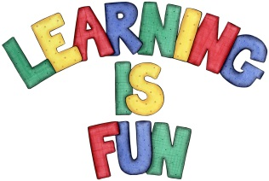
Date Set | 20/03/20
Date Due | 25/03/20
Mathletics | This week students learned about time as well as angles on shapes. Children should continue to practice their numeracy on the activities provided on matheletics.com. Every child has their username and passwords in their reading records.
Spelling  Writing | This week children will be focusing on these words:  preparation anonymous station enormous vibration generous decoration joyous duration ridiculous  In class we have been learning how to write and perform poems. This week we would like you to find any narrative poem of your choice and highlight its features using a key. For example, all similes can be highlighted red and all rhyming words can be highlighted blue. You need to look for the following:  - Simile  - Alliteration  - Rhyme  - Repetition.  - Do you like the poem? Why?
Reading | Recommended daily reading time:  KS2 40 minutes.
Home Learning Project
Greek | Please go to Greek Class Blog for Greek Home Learning  Greek Class - St Cyprian's Greek Orthodox Primary Academy

