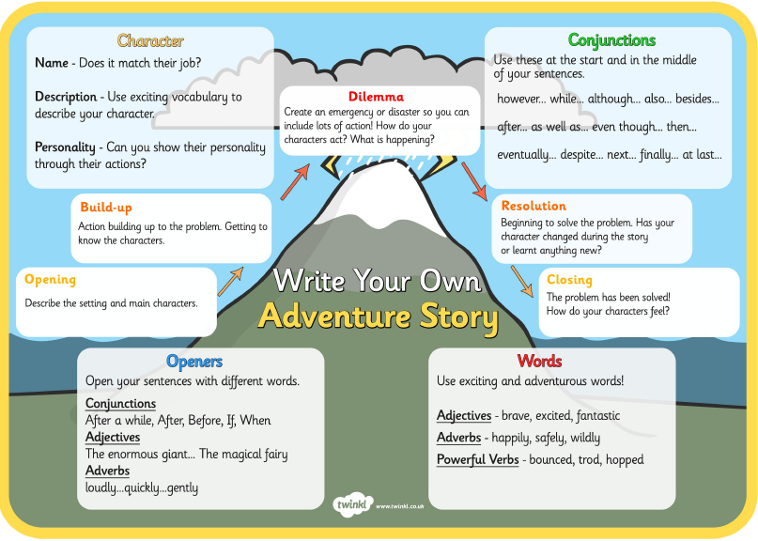

RESOLUTION:

Begin to solve the problem, has your character changed?

CLOSING:

Problem has been solved, how do the characters feel?

RESOLUTION:

Begin to solve the problem, has your character changed or learnt anything new?

PROBLEM:

Create another emergency problem! What happens to your characters?

OPENING:

Describe setting and main characters.

BUILD UP:

Action building up to the problem, get to know characters.

PROBLEM:

Create an emergency problem! What happens to your characters?