YEAR 5 HOME LEARNING
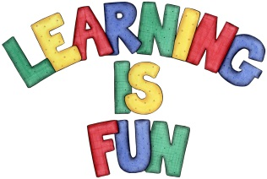
Date Set | 6/3/20
Date Due | 11/3/20
Mathletics | This week will be focussing on written calculations – Multiplication and Division  The children will need to log on to their Mathletics accounts that can be accessed form mathletics.com
Spellodrome | This week, children will be focusing on double consonants  Spellings can also be found on spellodrome.com  - accompany  - according  - accumulate  - anniversary  - appalled  - apparatus  - aggressive  - cappuccino  - embarrass  - embassy  - gimmick  - harass  - spaghetti  - bassoon  - satellites  - colossal  - community  - corrode  - mayonnaise  - composition
Writing | In line with our new topic ‘Living things and their Habitats’, this week children will be researching the life cycle of an animal of their choice. The animal can be an amphibian, reptile, mammal, bird or insect. Children must ensure that their text includes:  - an introduction and conclusion  - subheadings and paragraphs  - information written in chronological order  - complex sentences and fronted adverbials  - a range of vocabulary  - time connectives
Reading | Recommended daily reading time:  KS2 40 minutes.
Home Learning Project | Date Set: N/A Date Due:
Greek | Please go to Greek Class Blog for Greek Home Learning  Greek Class - St Cyprian's Greek Orthodox Primary Academy

