Wombat Fact-File

What is a wombat?
Wombats are short-legged, muscular marsupials. A marsupial is an animal that gives birth to live young, which they carry and feed in a pouch. Wombats can grow to about 1 meter and can weigh as much as 30kg (which is the same as 200 bananas!).

Where do wombats live?
Wombats live in Australia and some of the small islands surrounding Australia.

What do wombats eat?
Wombats are mainly nocturnal and emerge at night to feed on grasses, herbs, bark and roots. The incisor teeth of a wombat are continually growing, so to keep them in check wombats gnaw on bark and tough vegetation.

Why do wombats burrow?
Wombats have wide, barrel shaped bodies and strong feet with long claws which mean they are made for digging. Wombats excavate extensive systems of tunnels and chambers. Wombats sleep, rest and raise their family in the burrow.

What’s special about a wombat?
- A wombat’s pouch is unusual among marsupials because it faces backwards towards the rump (the area around its bottom). This is so the wombat won’t spray mud into the pouch when it is digging.
- Wombat poo is shaped like a cube. This is because wombats mark their territory using the scent from their poo and having cube shaped pooh stops it from rolling away.
- Wombats have a tough rump. When they feel threatened, a wombat will dive into a tunnel, blocking the entrance with its rump. The sturdy rump prevents predators from being able to remove and attack the wombat.

Unit 1: Day 1: Preparation
- Cut out wombat’s achievements.
- Match each achievement to the correct day of the week.
Wombat’s Week

Monday | slept and ate
Tuesday | slept, ate and scratched
Wednesday | slept, had a dustbath, battled and ate
Thursday | slept, scratched against a table leg and bashed up a rubbish bin
Friday | slept, scratched against a ladder, ate carrots and dug a hole
Saturday | moved into new hole, ate carrots and slept
Sunday | slept, found carrots by the back door, demanded rolled oats, ate rolled oats
Monday | slept, trampled on washing, demanded and ate carrots and rolled oats, dug a new hole and slept

Unit 1: Day 2: Activity

- Read each day of the week.
- Think about wombat’s achievements.
- Make notes to record your ideas.
- Orally convert notes into sentences.
Wombat’s Week

Monday
Tuesday
Wednesday
Thursday
Friday
Saturday
Sunday
Monday

Unit 1: Day 2: Easier
Days of the Week

- Cut out and sequence the days of the week.  - Make notes on sticky-notes to record wombat’s achievements for each day.  - Orally convert the notes into sentences, in the first person and past tense.  - Stick the days of the week and the sticky-notes for each day in a vertical list on a wide strip of A1 paper. | Monday | Tuesday
Wednesday | Thursday | Friday
Saturday | Sunday | Monday

Unit 1: Day 2: Harder
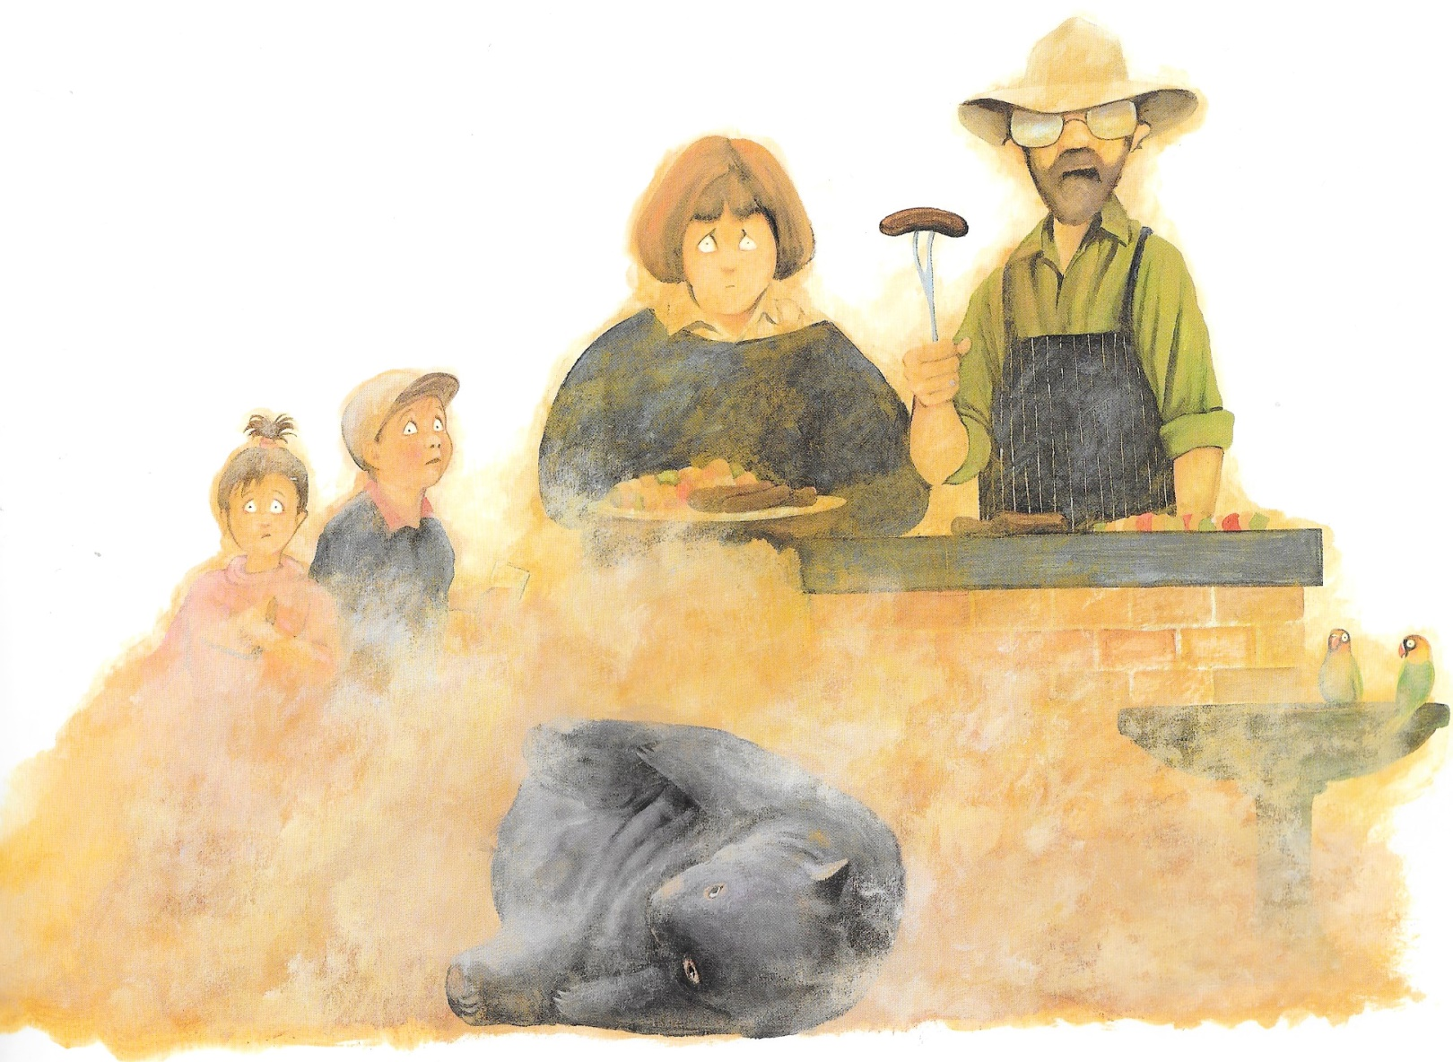
Diary of a Wombat
Unit 1: Day 3: Input
Diary of a Wombat
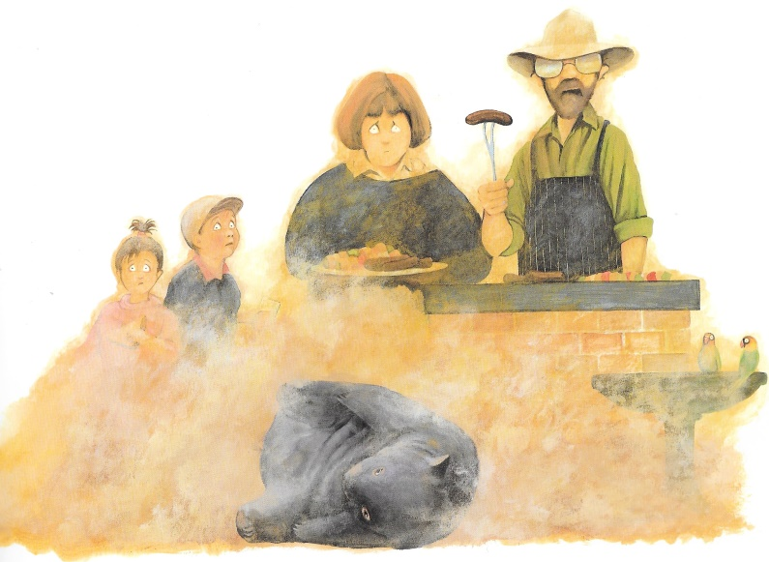
Unit 1: Day 3: Activity and Input
Wombat’s point of view
Family’s point of view

Diary of a Wombat
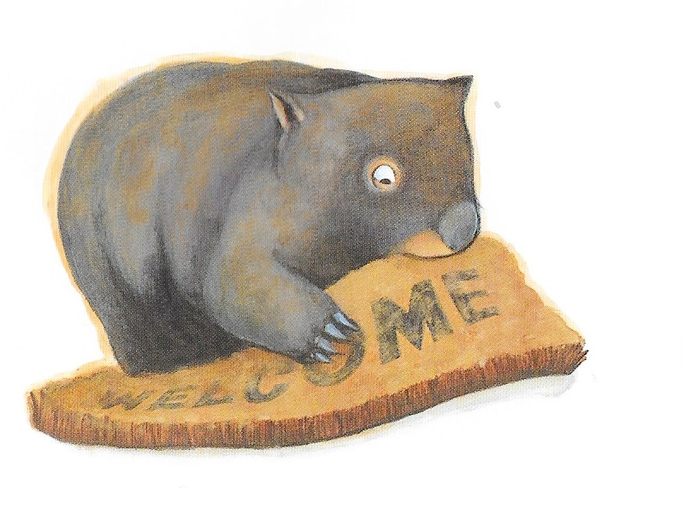
Unit 1: Day 3: Activity and Input
Wombat’s point of view
Family’s point of view

Diary of a Wombat
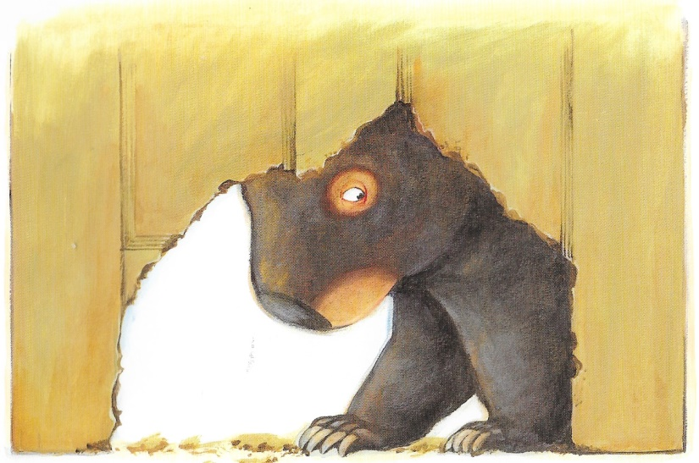
Unit 1: Day 3: Activity and Input
Wombat’s point of view
Family’s point of view

Diary of a Wombat
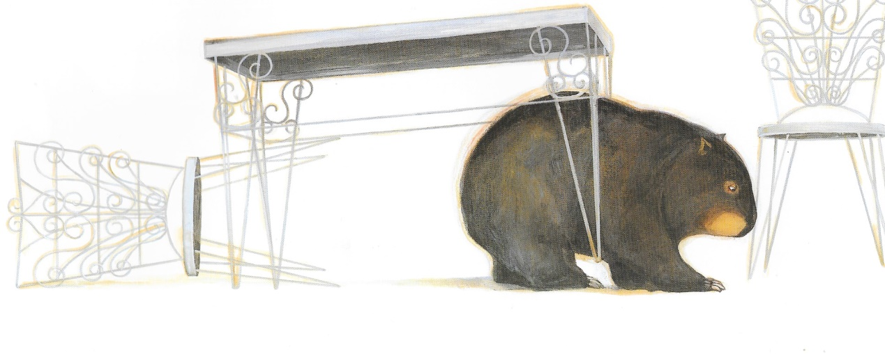
Unit 1: Day 3: Activity and Input
Wombat’s point of view
Family’s point of view

Diary of a Wombat
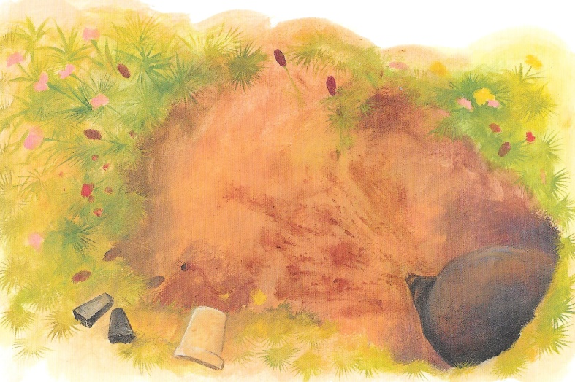
Unit 1: Day 3: Activity and Input
Wombat’s point of view
Family’s point of view

Wednesday

Morning
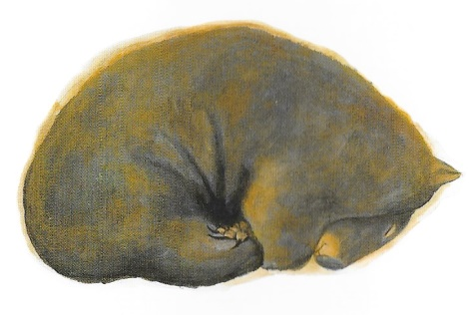

Afternoon
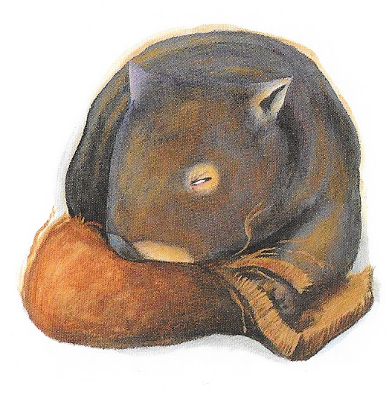
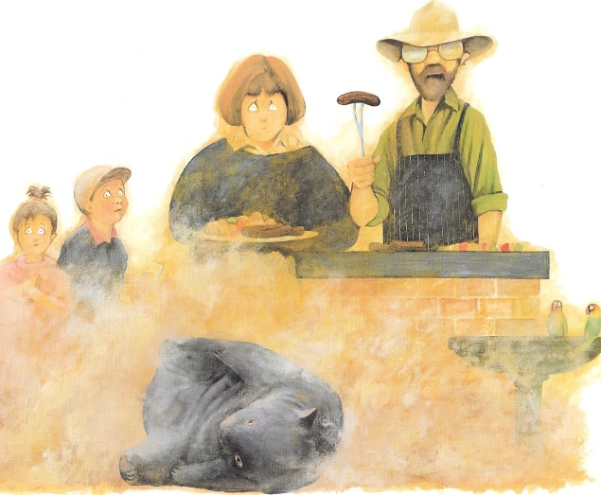

Evening
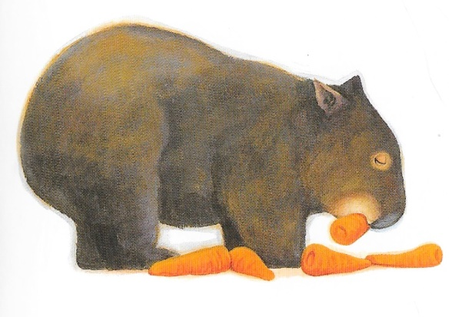
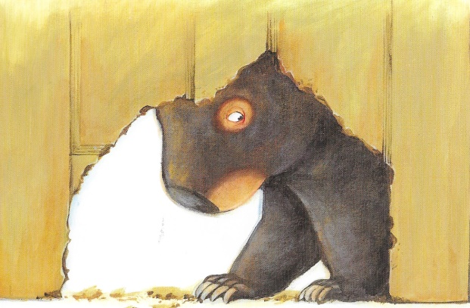

Unit 1: Day 4: Input

Wednesday

Morning | I woke up and got dressed. The
 | wombat was very quiet. I expect she
 | decided to sleep in, as usual. We did
 | wonder if she had decided to leave our
 | garden and find a new home. At least
 | she didn’t disturb us.
Afternoon | We had a family barbecue. I was just
 | about to eat a sausage when the silly
 | wombat had a dustbath right in front
 | of us. Sand went everywhere. After
 | that we found she had eaten our
 | doormat. I was furious.
Evening | We heard a funny noise coming from
 | the backdoor and discovered the
 | wombat had scratched a large hole in
 | it. She looked hungry so we gave her
 | carrots, which she seems to enjoy. I
 | must buy more carrots tomorrow!
Unit 1: Day 4: Input: Example Diary Entry
Friday

Morning
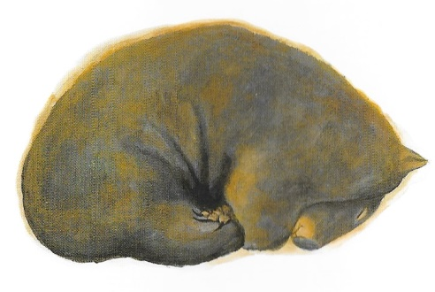

Afternoon
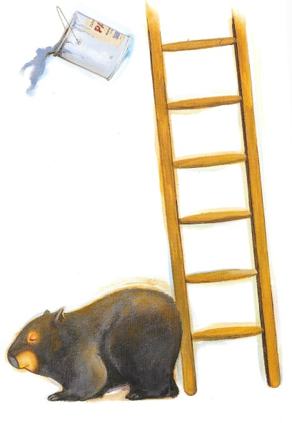
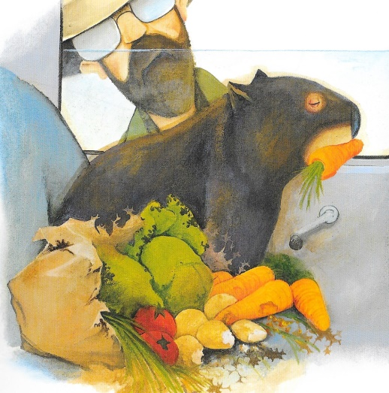

Evening
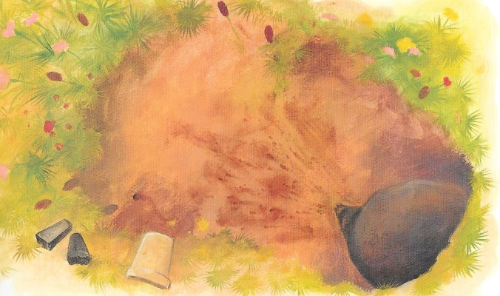

Unit 1: Day 4: Activity
Friday

Morning
Afternoon
Evening
Unit 1: Day 4: Activity

