Windrush
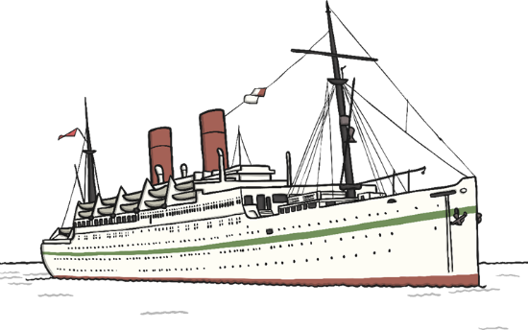
HMT Empire Windrush began sailing in 1930. It was originally used as a cruise ship and passenger liner. However, during the Second World War, she was used as a troopship. At first, she was used to transport German troops from country to country but was then taken over by the British Army to carry British soldiers. On one disastrous journey back to the UK in 1954, a fire broke out killing four engine crew members. Fortunately, all 1276 passengers were saved before she sank in the Mediterranean Sea. The wreck still lies 2600 metres below the surface of the sea. One of Empire Windrush’s most famous journeys was in 1948. After many young men and women lost their lives during World War II, Britain had a shortage of workers and needed more labourers. The British government invited people from Jamaica and other British colonies to come and work in the UK. Therefore, the Empire Windrush was sent to collect 492 people from Jamaica and bring them back to London. These people worked in industries such as transport, rail and the National Health Service. Although many of them only planned to stay for a few years, the majority stayed in the UK permanently and have been a huge influence in changing British culture.

