YEAR 2 HOME LEARNING
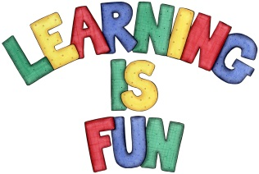
Date Set | 11.9.20
Date Due | 16.9.20
Mathletics | On Matheletics focus on addition using a number line to make number bonds to 20 and beyond. Please practice and learn the 2, 5 and 10 times tables.All activities can be found on matheletics.com. Every child has their username and passwords in their reading records.
Spellodrome  Writing | The home learning challenge for this week is to research your class island and create a poster about Crete or Santorini. You must include the following facts:  - Climate  - Food  - History  - Pictures  - Fun Facts  You must write at least a page.  Spellings to learn this week:  - the  - today  - said  - badge  - edge  - bridge  - dodge  - fudge
Reading | Recommended daily reading time:  KS1 20 minutes.
Home Learning Project | Date Set: N/A Date Due:
Greek | Please go to Greek Class Blog for Greek Home Learning  Greek Class - St Cyprian's Greek Orthodox Primary Academy

