YEAR 2 HOME LEARNING
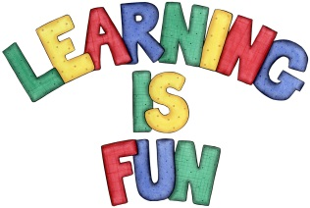
Date Set | 9.10.20
Date Due | 14.10.20
Mathletics | On Matheletics focus on the multiples of 2,3,5 and 10 and learning how to sequence numbers. Additionally, focus on calculating capacity using litres. All activities can be found on matheletics.com. Every child has their username and passwords in their reading records.
Spellodrome  Writing | The home learning challenge for this week is to make a fun and creative poster about either Mary Seacole or Windrush. You can choose which one you would like to research. In your poster you will need to include:  - Headings  - Sub-Headings  - Bullet Points  - Big Bold and Colourful writing  - Photos and Illustrations  - Captions and labels  - Fun Fact Box  Your home learning project for the next two weeks is to design and create a bonnet. (The bonnet is due in on 21.10.20 or can be handed in before.)  Spellings to learn this week:  - where  - love  - come  - some  - race  - ice  - cell  - city  - fancy  Over this term please start practising and learning the 2, 5 and 10 times tables and the inverses (division.) There will be a times table challenge every Friday along with the spellings.  If you are confident in these then start on the 3, 4 and 6 times tables.  Homework is due in on Wednesday 14th October 2020
Reading | Recommended daily reading time:  KS1 20 minutes.
Home Learning Project | Date Set: N/A Date Due:
Greek | Please go to Greek Class Blog for Greek Home Learning  Greek Class - St Cyprian's Greek Orthodox Primary Academy

