YEAR 3 HOME LEARNING
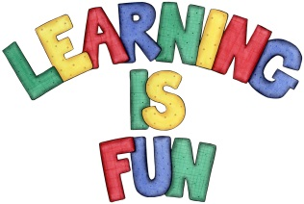
Date Set | 16.10.20
Date Due | 21.10.20
Maths | This week will be focussing on our 2,3 & 4 times table. We will also be rounding to the nearest 10.
Spelling  Writing | This week children will be focusing on words ending in the suffix -ly.  - unable  - unafraid  - unaided  - unaware  - unbeaten  - unblock  - uncertain  - unclean  - unclear  Writing Task  This week is inclusion week, we would like the children to research any black influencers from past or present. Then they should present their findings in any form they choose. For example, children can write a report, draw a portrait, make a poster, write a poem or a song.
Reading | Recommended daily reading time:  KS2 40 minutes.
Greek | Please go to Greek Class Blog for Greek Home Learning  Greek Class - St Cyprian's Greek Orthodox Primary Academy

