YEAR 3 HOME LEARNING
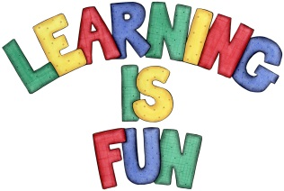
Date Set | 23/10/20
Date Due | 04/11/20
Mathletics | This week will be focusing our 2,3, 4 & 10 times table. We will also be looking at addition and subtraction word problems.
Spelling  Writing  Home Learning Project | - because  - don’t  - there  - their  - little  - who  - where  - people  - can’t  - have  We have read ‘The Magic Finger’ by Roald Dahl focusing on his use of dialogue. For your writing challenge we would like you to create a conversation between two fairy tale characters of your choice. You need to include in your writing:  - Inverted commas (“”) around the parts which are spoken.  - Different words for said (shouted, screamed, whispered, exclaimed).  - Starting a new line each time your speaker changes.  - Conjunctions to extend your sentences (because, but, so, when, if)  - Include full stops and capital letters in all of the correct places.  Write at least a page for your conversation.  The home learning project is to research the historical sources that tell you about the impact of the River Thames on London’s history. Find out about the history of the Regent’s Canal and City Road Basin. Create a poster, fact file or something imaginative. Date due: 6.11.2020.
Reading | Recommended daily reading time:  KS2 20 minutes.
Home Learning Project | Date Set:23.10.20 Date Due: 06.11.20
Greek | Please go to Greek Class Blog for Greek Home Learning  Greek Class - St Cyprian's Greek Orthodox Primary Academy

