YEAR 3 HOME LEARNING
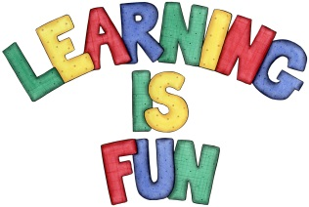
Date Set | 09.10.20
Date Due | 14.10.20
Maths | This week will be focussing our 2,3 & 4 times table. We will also be adding and subtracting 3 digit numbers using the column method.
Spelling  Writing | This week children will be focusing on words ending in the suffix -ly.  - boldly  - bravely  - kindly  - clearly  - cleverly  - deadly  - deeply  - exactly  - gladly  - kindly  Writing Task  In our Science lessons we have been learning about rocks, their appearance and physical properties. This week we would like you to write an information poster about different kinds of rocks and their properties Try to include:  - Title  - Headings and subheadings  - Statement sentences  - Interesting information  - Bullet points  - Captions  - Labels.
Reading | Recommended daily reading time:  KS2 40 minutes.
Greek | Please go to Greek Class Blog for Greek Home Learning  Greek Class - St Cyprian's Greek Orthodox Primary Academy

