YEAR 2 HOME LEARNING
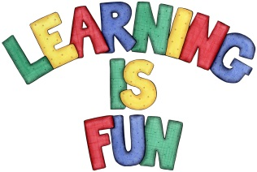
Date Set | 6.11.20
Date Due | 11.11.20
Mathletics | On Matheletics focus on addition and subtraction whilst partitioning numbers and calculating money. All activities can be found on matheletics.com. Every child has their username and passwords in their reading records.
Spellodrome  Writing | The home learning challenge for this week is to think of at least ten questions that you would like to ask your all-time favourite hero. It could be someone famous such as a singer or a famous footballer. You might even decide to choose a superhero, book character or a family member or friend. You must also include:  - An introduction to who your hero is and why you have chosen them.  - A drawing or a photo of them with a caption.  - Capital letters at the beginning of a sentence  - Who, Why, What, When, Where and How question openers (others can also be used.)  - To be even more spicy for some questions you may write two-part questions for example ‘What is your favourite food and why?’  Spellings to focus on this week  - write  - written  - wrote  - wrong  - wrap  - people  - because  Over this term please start practising and learning the 2, 5 and 10 times tables and the inverses (division.) There will be a times table challenge every Friday along with the spellings.  If you are confident in these then start on the 3, 4 and 6 times tables.  Homework is due in on Wednesday 11th November 2020.
Reading | Recommended daily reading time:  KS1 20 minutes.
Home Learning Project | Date Set: N/A Date Due:
Greek | Please go to Greek Class Blog for Greek Home Learning  Greek Class - St Cyprian's Greek Orthodox Primary Academy

